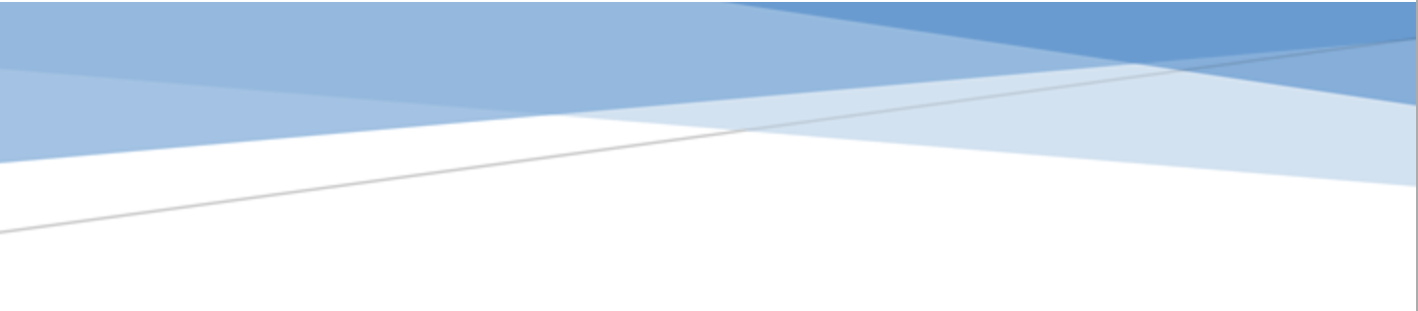



adges UI components library

**Component ID #1 – ex-news-details - v1.0.0**

## Document Control

## Version History

|  |  |  |  |
| --- | --- | --- | --- |
| Version | Date | Author | Reason for Change |
| 1.0.0 | 10/14/2019 | Tawfik |  |
| 1.1.0 | 09/24/2019 | Rijin Mukundan |  |
|  |  |  |  |
|  |  |  |  |
|  |  |  |  |
|  |  |  |  |
|  |  |  |  |
|  |  |  |  |

## Review History

|  |  |  |
| --- | --- | --- |
| Version | Reviewer | Date |
|  |  |  |
|  |  |  |
|  |  |  |
|  |  |  |
|  |  |  |
|  |  |  |
|  |  |  |

Table of Contents

Document Control 1

Version History 1

Review History 1

1. Document and components Purpose. 3

2. General Information. 3

3. How to use. 3

4. Component features and configure. 4

5. How to configure component. 4

6. Examples 4

# 

# Document and components Purpose.

The purpose of the document is to guide how use and configure **ex-news-details** component.

# General Information.

Component Name: News-details.

Extension Theme: ex-news-details.

Owner: Tawfik.

Version no: v1.0.0

Design

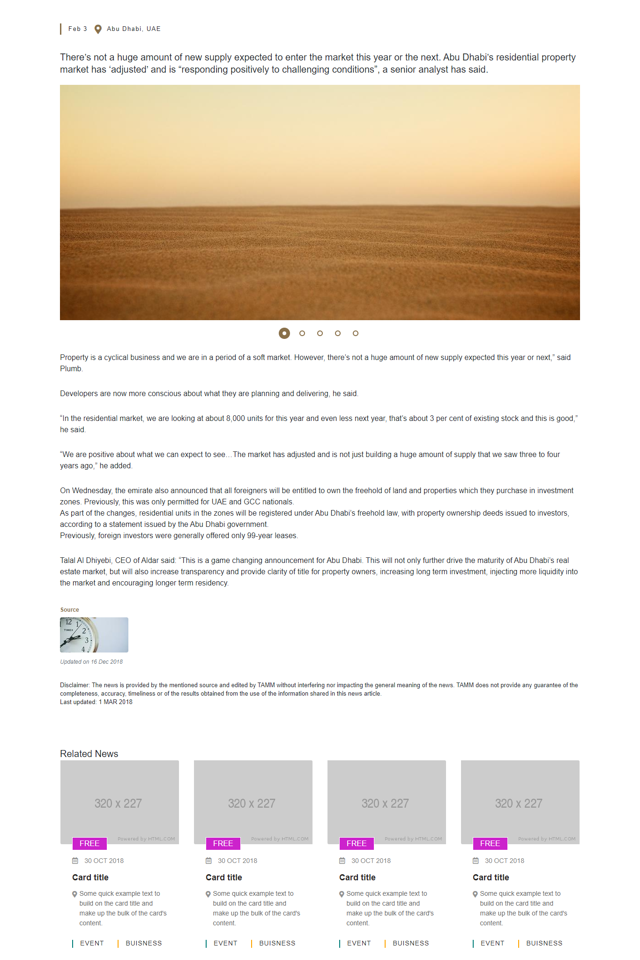

# How to use.

1. The available commands for this project .
   1. Compile : npm run gulp compile -- –path ex-news-details –extension
   2. Compile & include under ADGE tenant : npm run gulp compile -- –path ex-news-details –extension –full –dest [ADGEFolder]
   3. Deploy : npm run gulp deploy -- –path ex-news-details –extension
2. *Now project have full copy from this extension theme under the project theme and you can apply the project brand guideline and configure component based on project needs.*

# Component features and configure.

You have access now to configure component with the below item.

|  |  |  |
| --- | --- | --- |
| Feature | Variable | Default value |
| Owl dots border color not active state | $newsdetails-owldots-border-color: | $primary-color |
| Owl dots border style not active state | $newsdetails-owldots-border-style | solid |
| Owl dots border width not active state | $newsdetails-owldots-border-width | 2px |
| Owl dots border size width and height not active state | $newsdetails-owldots-size | 12px |
| Owl dots border background not active | $newsdetails-owldots-active-background | $white-color |
| Owl dots border-raduis | $newsdetails-owldots-border-radius | 50% |
| Owl dots border spacing left and right | $newsdetails-owldots-margin | 0 13px |
| Owl dots border display | $newsdetails-owldots-display | inline-block |
| Owl dots active state border by shadow | $newsdetails-owldots-box-shadow | 0 0 0 6px |
| Owl dots alignment to container | $newsdetails-owldots-text-align | center |
| Owl dots wrap container vertically | $newsdetails-owldots-wrap-margin | 17px 0 27px 0 |
|  |  |  |
| Title of fig caption size | $newsdetails-caption-font-size | 13px |
| Caption font size of fig caption | $newsdetails-figcaption-fontsize | 12px |
| Color of fig caption | $newsdetails-figcaption-title-font-color | $primary-color |
| Line height of fig caption | $newsdetails-figcaption-line-height | 2.67 |
| Caption font size | $newsdetails-date-time-font-size | 13px |
| Date and location of news letter spacing | $newsdetails-date-time-letter-spacing | 1.5px |
| Date and location of news border | $newsdetails-date-time-time-border-style: | 3px solid |
| Date and location of news border color | $newsdetails-date-time-time-border-color | $primary-color !default; |
| Date and location of news padding of time only | $newsdetails-date-time-time-padding | 0 15px |
| Date and location of news icon font size | $newsdetails-date-time-address-i-font-size | 20px |
| Date and location of news line height | $newsdetails-date-time-address-i-line-height | 1 |
| Date and location of news space | $newsdetails-date-time-address-i-margin-right | 10px |
| Date and location of news icon color | $newsdetails-date-time-address-i-color | $primary-color |
| Date and location of news font size | $newsdetails-default-fontsize | 16px |
| Date and location of news line height | $newsdetails-default-lineheight | 24px |
| Date and location of news lineheight | $newsdetails-p-caption-line-height | 1.46 |
| Disclaimer color | $newsdetails-p-caption-color | $primary-color |

# How to configure component.

There are various ways to configure the component:

1. **Adding Built-In or Bootstrap Class (on the variant)**
   1. Spaces, Font weights, Display, Position properties etc can be added by bootstrap classes
      1. i. Spacing: <https://getbootstrap.com/docs/4.0/utilities/spacing/>
      2. ii. Flex: <https://getbootstrap.com/docs/4.4/utilities/flex/>
      3. iii. Font: <https://getbootstrap.com/docs/4.0/content/typography/>
   2. These classes should only be added to match the design
   3. For built-in classes check 7 Below to see the entire list
2. **SCSS Variable Override (on the _override.scss file)**

To configure the component we can take the above variables from section **4. Component features and configure** and add them to: adge-ph2/themes/<ADGE>/vars/_override.scss, this file with your desired changes to match the design.

1. **Complete style override**
   1. This should be the last and final option if the above 3 didn’t get you the desired output
   2. This is overwriting the SCSS of the component by adding your own style to it
   3. **Note: Take permission before doing this override**
   4. Instructions:
      1. Open the file /adge-ph2/themes/<ADGE>/sass/overrides.scss and add your own SCSS styles to override the faulty component.

# Dependencies

components-news-cards.css

components-news-details.css

owl-carousel-min.js

owl-init.js

# Examples

Examples1:

I need to change carousel dots color.

I’ll copy the below variables from extension theme.

$newsdetails-owldots-border-color:$primary-color !default;

Then will paste the above variable in project folder theme in file _custom.scss and change with any variable based on site needs.

$newsdetails-owldots-border-color: $secondary-color;

Examples2:

I need to change icon location time of the current news .

I’ll copy the below variables from extension theme.

$newsdetails-date-time-address-i-color:$primary-color !default;

Then will paste the above variable in project folder theme in file _custom.scss and change with any variable based on site needs.

$newsdetails-date-time-address-i-color:$secondary-color;